MDM

Implementation ducument

Document Identifier :
Product Acronym | Product Version | Document  Version
MDM | 8.3.2 | 1.0
Copyright Notice

Trademarks

Confidentiality

Content Warranty
Table of Contents
TIBCO CIM (Collaborative Information Manager) 1
Functional Specification 1
1 References 5
2 Glossary 6
3 Overview 7
4 UI structure 8
5 Implementation 9
5..1 AngularJS route : 9
5..2 Modules: 9
5..3 Management and Testing 14
6 Future plan 15

Document Change History
This section serves as the area for recording change history of the Document itself. Please do keep track of the initial document creation, major and minor revisions.
Version | Date | Author(s) | Change Description
1.0 | 1/27/2014 | Ron, Summer | Initial draft

References

Doc Type | Doc Title | Location & Revision

Glossary
Terminology or Acronym | Description
MDM | Master Data Management
XML | Extensible Markup Language

Overview
The Configurator application uses an external container to execute, largely due to the use of supporting initial system setup.

UI structure
1 AngularJS route :
The following is the screenshot of the files architecture:

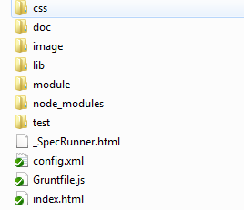
Figure 1
We build this Configurator program as an AngularJS web app. The index.html file is the entry of this app.
When you run the Configurator's Server, you can access the program on the way of visit index.html. Then the related necessary files will be loaded, such as JS, CSS, the localization JSON file etc. Following is the detailed path of these files:
- "CSS" folder includes all common CSS files
- "image" folder includes some icons in this app
- "lib" folder includes all the third-part lib the app depends on
- "module" folder is the mainly develop folder, including all AngularJS directives, controllers and services developed by different modules
- "node_modules" folder includes grunt task modules for code inspection, code integration and Jasmine test.
- "test" folder includes some E2E test code

Implementation
Based on the functional requirement of Configurator, the whole app is divided into several modules: login, home, revision history, tools and settings. Each module can load different templates depending on route module in AngularJS. The following section will explain these modules and the related technology implementation in detail.

AngularJS route :
AngularJS route is used for deep-linking URLs to controllers and views(HTML templates). It watches the URL changing and tries to map the path to an existing route definition. At Configurator app, it combine the ngView directive to implement the page refresh. When the route path changed, the related HTML template will be loaded into the ngView DIV tag. And the template includes some controllers, these controllers will complete the page load and data binding.
For example, when the route path is /configuration, the app will load the "module/tibco.mdm.configurator/view/template.html" file and execute the "module/tibco.mdm.configurator/controller.js" file to implement the page rendering and data binding.

Modules:
This section we will explain some important modules we developed for the configurator app.

Home
When login succeeds, user will access to the home page.
The navigation bar displayed in this page is implemented by a directive. The path of this directive is "module\tibco.ux.directive\uxMenuBar". In this directive, we use requireJS to load and read the config.xml file. This XML file contains the configure information of this navigation bar. In this way, we can only modify the config.xml file to change the content or functions of the navigation bar.

There are many sub-templates in the home page. And each template has their relevant controllers. Based on the AngularJS operation rules, when templates are loaded, the relevant controllers will run to complete the data binding and display.
At home page, the controllers control the data from server. They send request to server to acquire the data of Cluster, Configuration and Configure Values, and show the data to the web page. User can edit, clone and delete the data of Cluster and Configuration. The controller will watch the whole data, once the data is changed by user, they will send the new data to the sever. And the server side will maintain a cache file to save these user change.

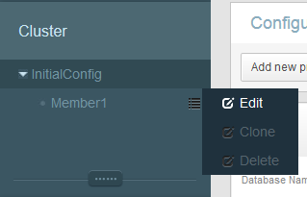
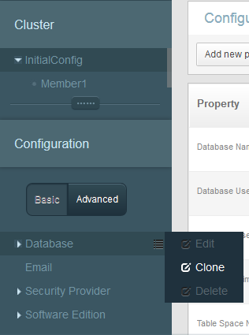
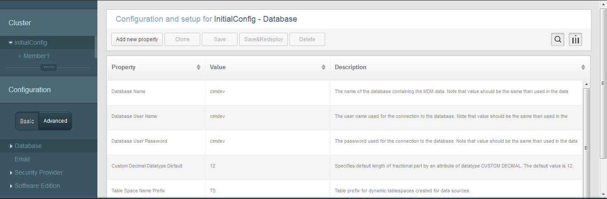

Every time the data changes, the controllers will send the newest data to the server side. When user clicks "save" or "save & deploy" button to save the data modification, the controllers will send the relevant request to info the server side to store the data files.

Restore
As the same way of home page's path logic, when the URL path is "config/index.html#/revision_history", the app will run the restore page. There's also some controllers in this page, and these controllers can show the template and bind data in the same way. The data in revision history can be edited and deleted. User can choose one vision to restore. Then the home page will show this vision's data.
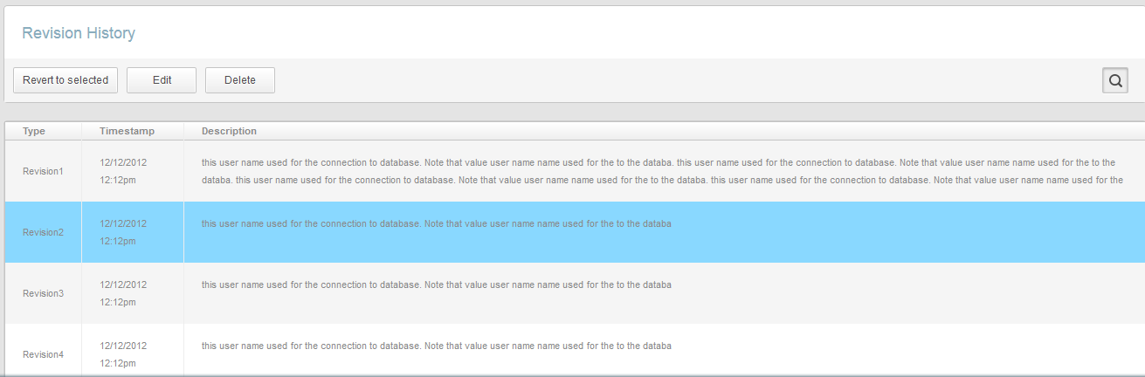

Tools
There are some tools in Configurator. Considering the functional requirement of these tools, we created a dialog wizard component to implement each tool wizard. We developed an angularJS directive to control each wizard. And create a service to write and read the relevant wizard information. The specific program code you can check "module\tibco.ux.directive\uxWizard" folder to get its detail. By using this uxWizard directive, we can just add some templates and controllers to complete each wizard dialog. You can find the code at "module\tibco.mdm.configurator\tools" folder. There are "define new queue", "setup basement(Oracle)", "Setup basement(SQL)", "migration", "add-on plug-in installer" in the tools. It's easy to find that each tool wizard has a unique folder. The controllers in each folder control and manage their templates.
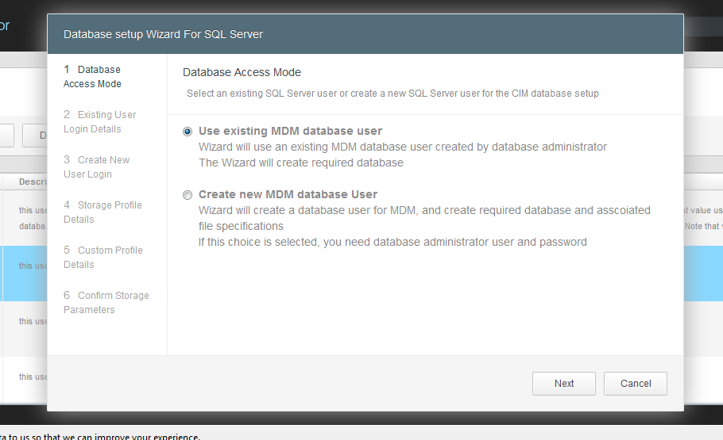

Setting
In settings page, the path is " config/index.html#/settings". The implementation way of this page is very similar to the way of home page and restore page. The data shown in the page is based on the server side request. Following is the data format in setting page:
[ {
name : "Database",
value : "Oracle",
panelSrc : "oraclePanel",
panelShow : false,
panelConfig : [ [ {
type : "radio",
value : "Oracle"
}, {
type : "string",
value : "Oracle"
} ], [ {
type : "radio",
value : "PostGres"
}, {
type : "string",
value : "PostGres"
} ], [ {
type : "radio",
value : "SQL"
}, {
type : "string",
value : "SQL"
} ], [ {
type : "link",
value : "Add another",
mothed : ""
} ], [ {
type : "button",
value : "Save Changes"
}, {
type : "link",
value : "Cancel"
} ] ]

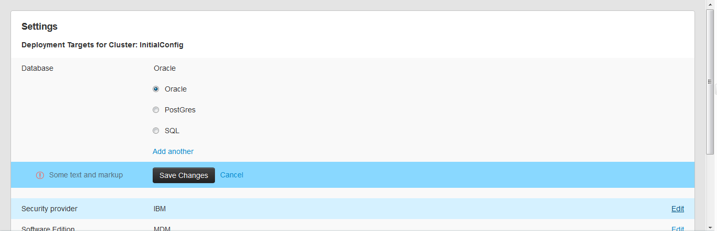

Management and Testing
We use Grunt to manage and inspect the program automatically. We divide the program into module at development stage, each module has its unique JS, CSS and image file. When we run the Grunt program, these divided files will be merged. In this way, the app can efficiently reduce the request and optimize performance.
We also user Grunt to run the Jasmine unit test. And we use angularJS protractor to do the E2E test.

Future plan
Optimize the component, performance and the development process.

